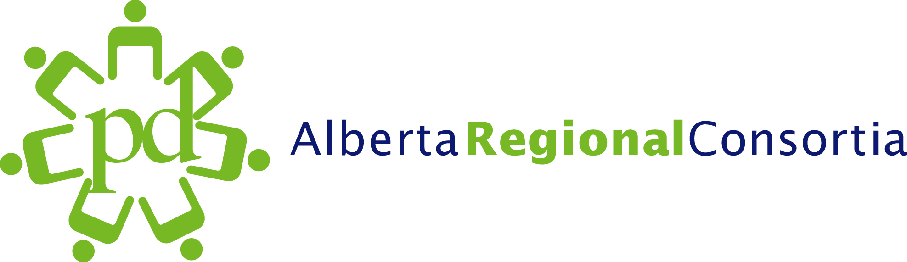





UDL Summer Institute: Alberta Stories of UDL in Action

Monday, August 22

Inclusive Learning in the 21st Century: Greater St. Albert Catholic Schools (Room 150)
In Alberta schools, the mix of students is more diverse than ever. Educators are challenged to teach all learners to high standards. Since 2005, Greater St. Albert Catholic Schools has been on a journey to create classrooms that are more accessible. In 2010, the division’s collaborative Learning Services Team articulated a vision of “Excellence in Learning for Every Student” based on a foundation of Universal Design for Learning. District initiatives include a Learning Support Facilitator Model, district-wide access to text-to-speech software, 1:1 laptop classrooms focusing on change in practice reflecting UDL principles, and at-the-elbow support in the areas of differentiating learning with technology. Examples of UDL can be found in every school. In 2011, school-wide implementation of UDL has been highlighted through the “Power Up2Learn” initiative at Richard Fowler Junior High School and through the “Fine Arts Media Enhancement” initiative at Vital Grandin School. This session will trace the implementation of division-wide implementation of UDL practices and make connections to Action on Inclusion through collaboration, capacity-building and curriculum.

Karen Pedersen-Bayus was recently seconded to Alberta Education’s Action on Inclusion Team from Greater St. Albert Catholic Schools where she has worked for 28 years as a Learning Support Consultant in the areas of Early Learning, Inclusive Education and Universal Design for Learning. She has a Masters Degree in Special Education from the University of Alberta and attended the Harvard UDL Summer Institute in 2010.

Universal Design in Learning at NorQuest College (Room 236)
This presentation provides an overview of the activities the Centre of Excellence in Learning Supports has undertaken over the past 3 years to promote Universal Design in Learning at the College. Activities include applied research, policy development, presentations and lots of talking. The presentation will also touch on future activities being planned to promote UDL throughout the College.

Brenda Reitsma is the Principal of the Centre for Excellence in Learning Supports at NorQuest College. A graduate of the University of Waterloo with a Joint Honors BA in Recreation & Psychology, she received her Masters in Educational Psychology, specializing in Special Populations from the University of Alberta. A lifelong learner, she has also taken certificate programs from the University of Alberta in Risk Management, Management and Program Supervision.

Building Capacity: Universal Design for Learning in Rocky View Schools (Room 134)
In this presentation, Dawn will introduce you to Rocky View Schools’ Learning Model and discuss the role of Universal Design for Learning (UDL) in that model. She will describe the history of the implementation of UDL in the district’s Emerge project and how that research has influenced teaching and learning in Rocky View. Specifically, Dawn will illustrate how the district is using a learning management system to build the capacity of staff in understanding UDL.

Dawn M. Rife, M.Ed. is the Assistant Principal of Rainbow Creek Elementary School in Chestermere, Alberta. Before entering school administration, she worked as a special education teacher, and as a district learning specialist responsible for supporting schools in the development of programs for students with special needs. She has also been part of Rocky View School’s Educational Technology team where she was responsible for supporting teachers in technology infusion, leading the district’s one-to-one computing project and developing an Assistive Technology program.

Tuesday, August 23

A District’s Journey through Assistive to Accessible Learning: Lakeland Catholic Schools (Room 236)
In 2008 Lakeland Catholic Schools began developing and implementing a district wide assistive technology (AT) plan targeted at increasing educational success of students identified with learning disabilities or students who were at risk due primarily to their struggles with reading. This session presents a case study of the implementation journey. The wide scale deployment of assistive technology programs such as Read Write Gold, Clicker 5 (English & French), Word Q (French),Ghostwriter (French) and Boardmaker Plus was systematically supported in district goals, school based plans, professional development and ongoing developmental evaluation. The outcomes of this AT implementation will be shared focusing primarily on lessons learned and the district’s ultimate move towards Universal Design.

This will be a panel presentation lead by Michelle Dargis who is the Assistive Technology lead for Lakeland Catholic Schools. She has been working in the area of Special Education for a number of years, both at the middle school and elementary levels. Previous to her work in Special Ed. she taught kindergarten for 12 years. Michelle will be joined by other District staff to present the story of their journey.

Building Capacity for Creating More Inclusive Classrooms through Job-Embedded Consultation: Edmonton Regional Educational Consulting Services – ERECS (Room 150)
In this presentation, Belina and Colleen will introduce you to the Edmonton Regional Educational Consulting Services (ERECS) consultation model for supporting students with diverse learning needs and discuss the role of Universal Design for Learning (UDL) in that model. They will describe how the ERECS multi-disciplinary team provides support for school-based implementation of UDL. Specifically, the supports currently available through ERECS consultants to northern Albertan teachers to improve their capacity to provide curriculum access for students with low-incidence and severe disabilities will be shared.
Belina Carter-Pasula is an Assistive Technology for Learning Consultant with ERECS currently on a part-time professional improvement leave from Edmonton Public School Board to work on a doctorate in Educational Technology through the University of Calgary. Belina’s educational background includes post-graduate studies focused on learning, technology, inclusive and special education, psychology and english. Belina has been a teacher in inclusive and congregated settings and a consultant with 15 years experience supporting diverse learners.
Colleen McClure has been the Supervisor and Acting Director of ERECS for the last three school years. The ERECS team now includes a dedicated Assistive Technology for Learning team and has secured a few grants designed to support and evaluate the implementation of universal design for learning in schools. Colleen has been a supervisor, education manager, consultant, assistant administrator, instructor and teacher with 30 years experience assessing and addressing the educational and behavioural programming needs of students.

UDL in an Elementary School Classroom: Edmonton Public Schools (Room 134)
Classroom teachers today are faced with a diverse student population. Universal Design for Learning (UDL) is an educational philosophy and framework that enables classroom teachers to more effectively address the wide variety of learning styles and challenges in their classrooms. This session will describe how UDL can guide a change in the way educators support all students within an inclusive classroom setting. The presenters will also share the journey of an elementary classroom in which UDL has been implemented.

Sandra Gluth is a consultant in Student Learning Services for Edmonton Public Schools
Jody Lundell is the principal of Westglen School in Edmonton

Wednesday, Aug 24

UDL in Action: AT & mLearning: Supporting English Language Learners: Calgary Public Schools (Room 134)
Educators are increasingly seeking innovative ways in meeting the needs of their diverse student populations. In a three year initiative, the Calgary Board of Education focused on the impact that one-to-one mobile learning devices had on English Language Learners. The Presenter will share some of the ‘stories’ that emerged from the schools involved, focusing specifically on the impact that the one-to-one devices had on student learning and teaching practices and how this initial project has expanded to include an array of mobile devices and focuses on a broader student population.

Pauline Auld is a Learning Specialist within the Calgary Board of Education. Her work involves creating awareness around the potentials of new and emerging technologies in supporting diverse learner needs and in building capacity with CBE staff in how they can embed technology into the teaching and learning environment.

Universal Design for Learning in Black Gold Regional Division #18: Practical Application in the classroom (Room 150)
This session will focus on the practical application of UDL principles in the classroom supported by an instructional coaching model. In particular, various examples of technologies and strategies that have proven effective for working with teachers and enhancing student engagement and social inclusion, K-12 will be shared. Key to the success of implementing UDL practices in our schools has been the provision of active coaching support for teachers to allow for more effective planning, collaboration, and instruction.

As part of the Student Services Team, Rebecca Aiken is an Instructional Coach with background and expertise in the areas of special education, psychology, and assistive technology. She is currently working on a Master’s degree from the Department of Educational Psychology in Special Education at the University of Alberta. Rebecca’s coaching position was created as an extension of the district’s Making a Difference with Technology leadership project.

